Rulers Court UI Installation Guide

Contents

Initial Configuration 2

Release build instruction 2

Deployment Instruction 4

# Initial Configuration

Configuration need to be done by following attributes in the following file.

*/src/environments/environment.prod.ts*

  apiHostingURL : 'http://10.82.91.21/RrcApi/api',

  DownloadUrl: 'http://10.82.91.21/RrcApi/Downloads',

  AttachmentDownloadUrl: 'http://10.82.91.21/RrcApi/api/attachment/download',

  imageUrl: 'http://10.82.91.21/RrcApi/Uploads',

# Release build instruction

*This is the step for generating release build either using Visual Studio Code or command terminal.*

#### Installing dependencies

Install node.js (<https://nodejs.org/en/>)

Install angular cli (<https://angular.io/guide/setup-local#step-1-install-the-angular-cli>)

Please note that internet is required for this step.

Point the terminal/command window to the RRC.UI code as follows. Example:

*cd C:\source\RRC.UI*

and then run the following command for installing dependencies of the project

*npm install*

Following are the dependencies list. This will get installed with the above install command.

"@angular/animations": "^7.2.16",

"@angular/cdk": "^8.2.3",

"@angular/common": "^7.2.16",

"@angular/compiler": "^7.2.16",

"@angular/core": "^7.2.16",

"@angular/forms": "^7.2.16",

"@angular/http": "^7.2.16",

"@angular/platform-browser": "^7.2.16",

"@angular/platform-browser-dynamic": "^7.2.16",

"@angular/router": "^7.2.16",

"@ctrl/ngx-emoji-mart": "^0.17.0",

"@fullcalendar/angular": "^4.4.1",

"@fullcalendar/core": "^4.4.0",

"@fullcalendar/daygrid": "^4.4.0",

"@fullcalendar/resource-daygrid": "^4.3.0",

"@fullcalendar/resource-timegrid": "^4.3.0",

"@fullcalendar/resource-timeline": "^4.4.0",

"@fullcalendar/timegrid": "^4.4.0",

"@ng-bootstrap/ng-bootstrap": "^4.2.2",

"@ng-select/ng-select": "^2.20.5",

"@nicky-lenaers/ngx-scroll-to": "^3.0.1",

"@swimlane/ngx-datatable": "^15.0.2",

"@tinymce/tinymce-angular": "^3.4.0",

"angular-tinymce": "^6.0.0",

"angular2-tinymce": "^3.3.0",

"animate.css": "^3.7.2",

"bootstrap": "^4.4.1",

"chart.js": "^2.9.3",

"core-js": "^2.6.11",

"hammerjs": "^2.0.8",

"jquery": "^3.4.1",

"lodash": "^4.17.15",

"moment-timezone": "^0.5.28",

"ng-image-slider": "^2.4.0",

"ng-multiselect-dropdown": "^0.2.10",

"ng2-pdf-viewer": "^5.3.4",

"ngx-bootstrap": "^4.3.0",

"ngx-chips": "^2.1.0",

"ngx-datatable": "^1.0.3",

"ngx-editor": "^4.1.0",

"ngx-gallery": "^5.10.0",

"ngx-lightbox": "^2.1.2",

"ngx-owl-carousel-o": "^2.0.3",

"ngx-pagination": "^3.3.1",

"ngx-select-dropdown": "^1.3.1",

"ngx-tinymce": "^7.0.0",

"rxjs": "~6.3.3",

"tinymce": "^5.2.0",

"tooltip.js": "^1.3.3",

"tslib": "^1.11.0",

"zone.js": "~0.8.26"

#### Release build step

Following command should be run in the terminal to generate the release build.

*node --max_old_space_size=8192 ./node_modules/@angular/cli/bin/ng build --prod --build-optimizer=false --base-href=/rrcui/*

A dist folder will be generated in the path which is the release build ready for deployment.

# Deployment Instruction

Create a web site application name ‘rrcui’ in IIS for UI with the physical path generated in the ‘dist’ folder.

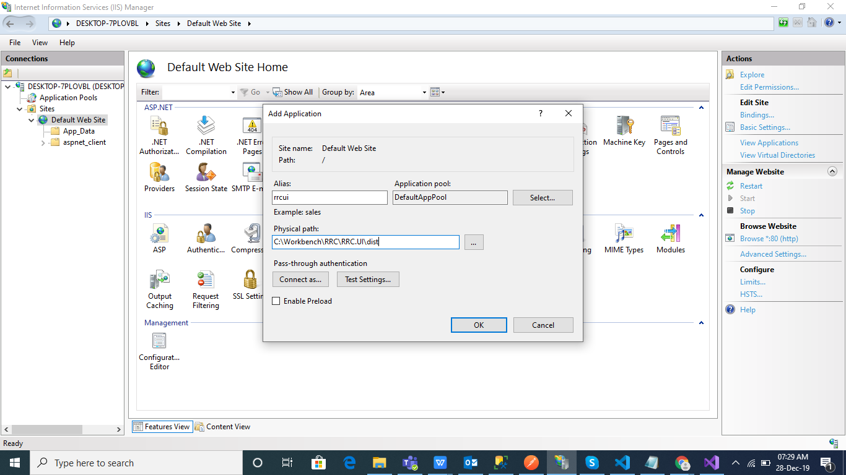

Visit the deployed site and the following login page should be up and running.

